
Minutes of the Meeting of Rangeworthy Parish Council
Held at 7.30pm on Tuesday 3rd March 2026
Lister Room, Rangeworthy Memorial Hall

……………………………………………………………………………………………………………

Present: Councillors W Moody (chair), MJ Steer, P Morse
Apologies Cllr Livall
In attendance: Mrs J Walkley(Clerk)
……………………………………………………………………………………………………………
WELCOME & PUBLIC PARTICIPATION
Members of the public were invited to raise any matters concerning the Parish (time allowed 20 mins maximum)
Councillor Moody opened the meeting and gave thanks to the Councillors and residents for the support and condolences received following her recent family bereavement.
--------------------------------------------------------------------------------------
- To note apologies for absence.
Apologies were received from Cllr Livall, these were noted and accepted.
- Declarations of Interest Relating to Agenda Items – (to receive and note declarations of a Disclosable Pecuniary, Other Non-Disclosable Pecuniary or Non-Pecuniary nature) or approve dispensations.
None received
- Minutes of the Previous Meeting - to RESOLVE to approve the minutes of Tuesday 3rd March 2026.
It was RESOLVED to accept the minutes as a true and correct record. The minutes were signed by the chair (noted minor spelling amendment to parish name, to be amended)
- To note matters arising from the minutes (unless agenda items)
APA date set for the 8th May at 7.30 in the village hall
Works expected to take place shortly by the Highways Team – list has been forwarded for consideration.
- To note training opportunities and agree actions
Noted – no requests received
- To consider tenders for grass keep and agree actions
No tender documentation received. Will readvertise and consider at next meeting prior to further considerations for land management.
- To receive requests to contribute to working group to agree arrangements for the Rag Lane solar farm funding.
It was RESOLVED that Cllr M Steer and Cllr Livall would act as external representatives on behalf of the council and attend the next meeting for the committee start up. Clerks from Wickwar, Cromhall and Rangeworthy had previously met to discuss and agreed the next actions required to move the committee forward. An annual sum would be made available but would require forming a new committee to oversee the funding distribution. Further meetings to be arranged.
Reports
- To receive reports from South Gloucestershire Councillors
A written report had been received and attached.
- To receive Clerk’s Report
Report noted, no issues raised
Planning - To consider Planning in the parish

- New Applications received
P26/00365/PIP
Land At Tanhouse Lane Yate South Gloucestershire BS37 7PZ
Permission in principle for the erection of up to 4no. dwellings.
P26/00523/PIP
Land Adjacent To The Old Plough Bagstone Road Rangeworthy South Gloucestershire
Permission in principle for the erection of a minimum of 2no. dwellings and a maximum of 3no. dwellings.
- New Decisions in the parish

Works to 1.no Oak tree (T1) to crown clean and remove deadwood. Covered by Tree Preservation Order SGTPO03/12 - 6th August 2012. Walnut Waverley Close Rangeworthy South Glos BS37 7BF
Ref. No: P26/00045/TRE - APPROVED

Erection of 1 No. detached self-build dwelling over existing redundant swimming pool structure, construction of detached garage and formation of new access, with associated works.
Land At The Old Forge Bagstone Road Rangeworthy South Gloucestershire GL12 8BD
Ref. No: P25/01548/F - APPROVED

Variation of condition 2 attached to planning permission P21/03370/F to amend the approved elevation plans to replace render areas to artificial stone - Erection of 2 no. detached dwellings with associated garages, parking and associated works.
Land At Kilgobbin House Wotton Road Rangeworthy South Gloucestershire BS37 7NB
Ref. No: P26/00107/RVC - APPROVED

Change of use of land from agricultural to residential (class C3) (residential curtilage) and the erection of 1 no. detached double garage.
The Paddocks Patch Elm Lane Rangeworthy South Gloucestershire BS37 7LU
Ref. No: P25/02815/F – APPROVED

- Appeals in the parish
No New appeals
Financial Matters
- To RESOLVE to approve the Bank Reconciliation for February 2026.
This was APPROVED, No issues raised
- To RESOLVE to approve Payments for March/April 2026
The payments list was APPROVED

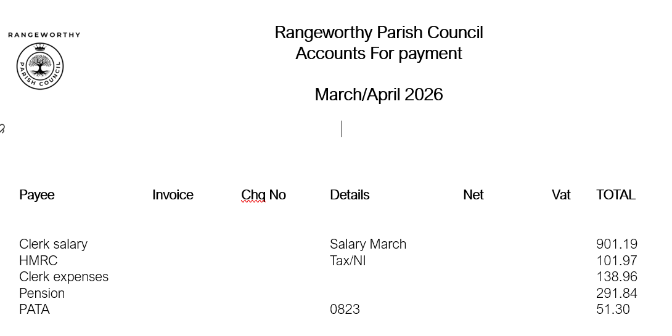

Sports Recreation Ground & Pavilion

- To agree contract for grass cuts for woodland track and sports pavilion field
It was APPROVED to accept the costings for the continued work of South Glos Council to undertake the grass cuts in 2026/27 as per below.
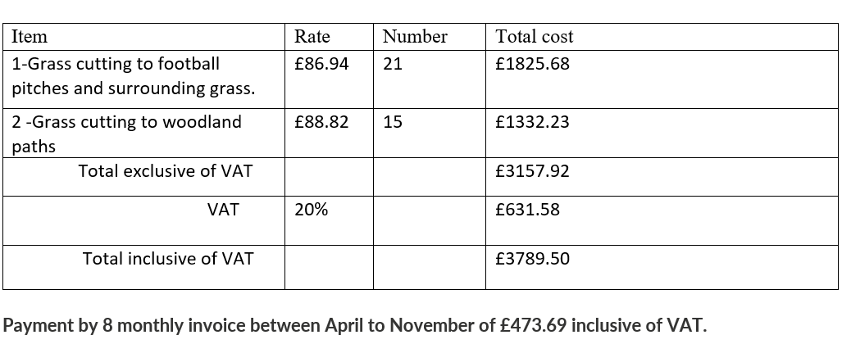

Children’s Playground

- To receive monthly inspection reports & review actions
Received, no new issues noted
- To agree increase in monthly inspection costs
It was AGREED to accept the increase for the litter picks from £60 to £65 per visit by KLH Landscaping and the annual contract was approved. Play area grass cut, strimmed and grass collected, area litter picked, leaves collected, the grass verge with the post box on it cut and strimmed and any long brambles cut back to the hedge line.
Total cost for x 16 cuts per season between March – November
£1040.00
- To consider requests for co-option
No co options requests had been received. It was agreed to be advertised again and opportunities raised at next meeting.
- To note issues relating to Highways, Car Park or Public Rights of Way.
Request update on green lane issues – SGC Cllr to make enquiries. Progress to invesitigation scheme.
- To receive updates on Parish Projects and agree actions

Pavilion Accessibility Improvements (track) - pending application
Pavilion Improvements - clerk to meet with football club to discuss S106 prior to bid submission.

- To note any other matters relating to Rangeworthy Parish – No resolutions to be made, future agenda items.
Newsletter article deadline dates – clerk to submit entry
Social media page – Clerk to progress
Pizza Van – Note support with SGC
Speed concerns in the parish – contact with police and consider a submission of highways improvement form
Litter pick – re-arrange date for 16th May. Clerk to rearrange equipment drop off.

Date of Next Meeting
5th May 2026

With no further business, the meeting was declared closed at 20.54

