Email: clerk@rangeworthyparishcouncil.gov.uk
http://www.rangeworthyparishcouncil.gov.uk/

TO ALL MEMBERS OF
RANGEWORTHY PARISH COUNCIL

You are hereby summoned to attend the MEETING of RANGEWORTHY PARISH COUNCIL at 7.30pm on Tuesday 7th April 2026 at the Lister Room, Rangeworthy Memorial Hall for transacting the business shown on the following agenda:

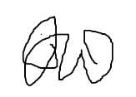

J Walkley (Mrs)
Clerk & Responsible Financial Officer 30th March 2026

WELCOME & PUBLIC PARTICIPATION
Members of the public are invited to raise any matters concerning the Parish (time allowed 20 mins maximum)
……………………………………………………………………………………………………………

- To note apologies for absence.
- Declarations of Interest Relating to Agenda Items – (to receive and note declarations of a Disclosable Pecuniary, Other Non-Disclosable Pecuniary or Non-Pecuniary nature) or approve dispensations.
- Minutes of the Previous Meeting - to RESOLVE to approve the minutes of Tuesday 3rd March 2026.
- To note matters arising from the minutes (unless agenda items)
- To note training opportunities and agree actions
- To consider tenders for grass keep and agree actions
- To receive requests to contribute to working group to agree arrangements for the Rag Lane solar farm funding.
Reports
- To receive reports from South Gloucestershire Councillors
- To receive Clerk’s Report
Planning - To consider Planning in the parish
- New Applications received
- New Decisions in the parish
- Appeals in the parish

Financial Matters
- To RESOLVE to approve the Bank Reconciliation for February 2026.
- To RESOLVE to approve Payments for March/April 2026
- Sports Recreation Ground & Pavilion
- To agree contract for grass cuts for woodland track and sports pavilion field
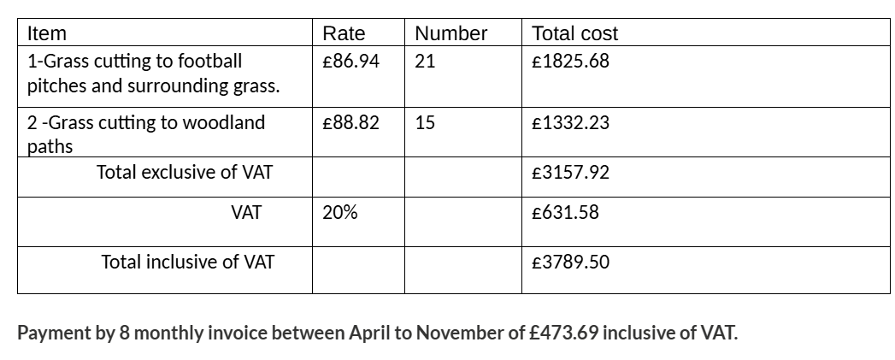
- Children’s Playground
- To receive monthly inspection reports & review actions
- To agree increase in monthly inspection costs
- To consider requests for co-option
- To note issues relating to Highways, Car Park or Public Rights of Way.

- To receive updates on Parish Projects and agree actions

- Pavilion Accessibility Improvements (track)
- Pavilion Improvements
- To note any other matters relating to Rangeworthy Parish – No resolutions to be made, future agenda items.

Date of Next Meeting

